**Ansible Installation and Working on Ubuntu machine**

This example works with one master Ubuntu machine and three node Ubuntu machines.

1. **Login to your Ubuntu machine and add user ‘test’. Give appropriate password for the added user.**

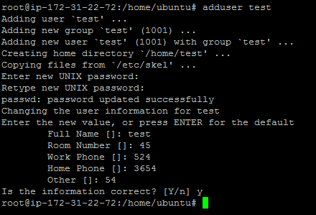

1. **Give privileges to the added user ‘test’. Navigate to the sudoers file using vi /etc/sudoers**



In sudoers file edit…

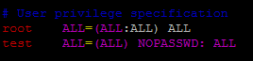

This means you are giving sudo privileges to ‘test’.

So you can execute sudo commands from ‘test’ without it asking for a password.

1. **Install python in the Ubuntu machine for the ansible to run**.

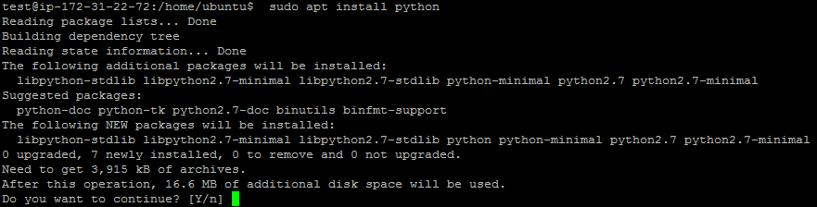

Now python is installed in the machine.

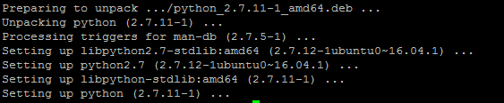

Perform the above steps in the node machines also.

**In node1:**

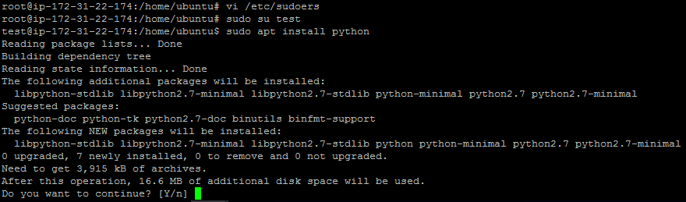

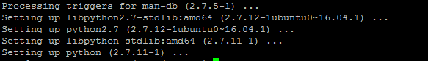

**Node2:**

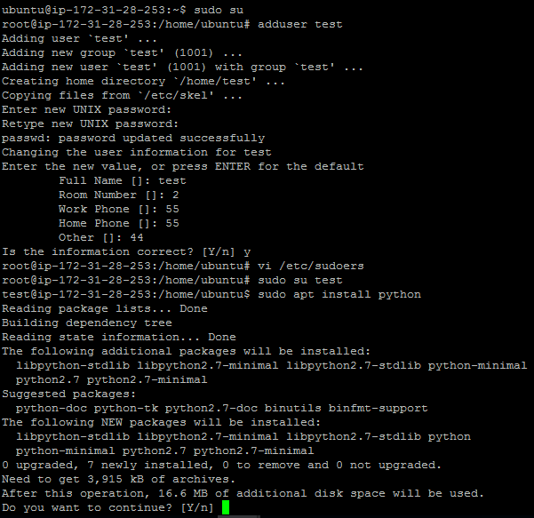

1. **In master machine, generate SSH-keys for establishing secured connection with nodes.**

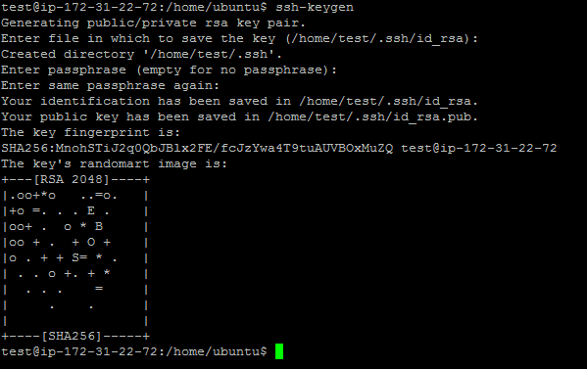

1. In master machine, We need to edit **ssh-config** file to give certain permissions. Navigate to **sshd_config** file and perform changes.



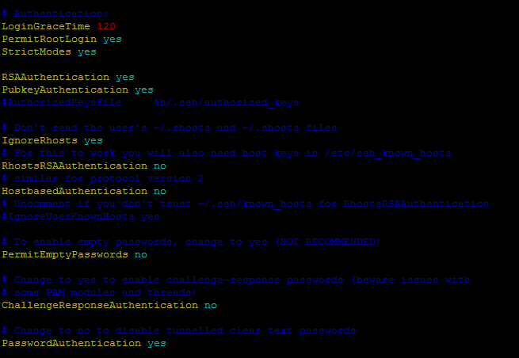

Restart the sshd file for the changes to be effective ‘systemctl restart sshd’



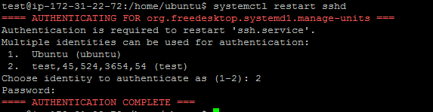

Perform the above step (5) in corresponding node machines also.

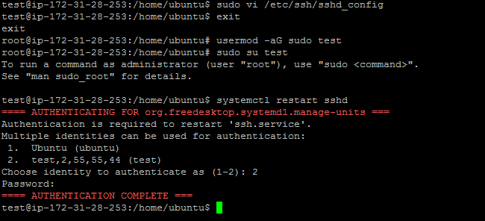

1. Now copy the generated ssh-keys to the node machines.

In master, execute the command ssh-copy-id test@node_ip

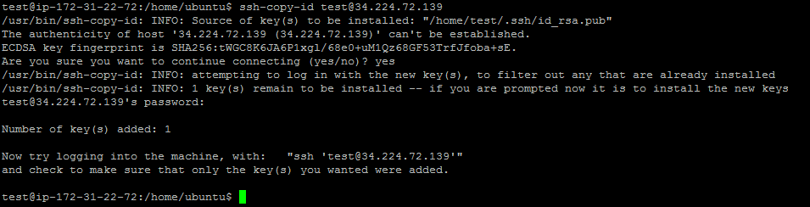

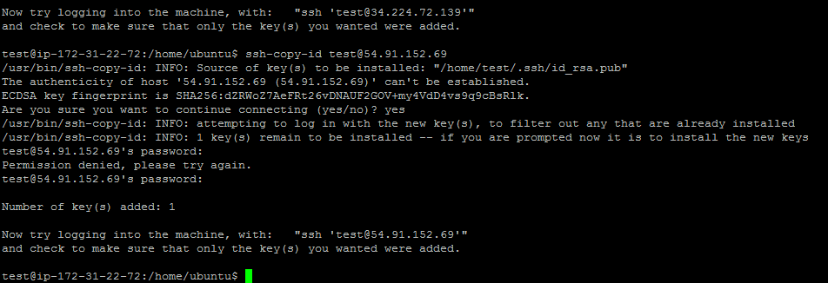

1. Now install Ansible in the master machine. “sudo apt install ansible”

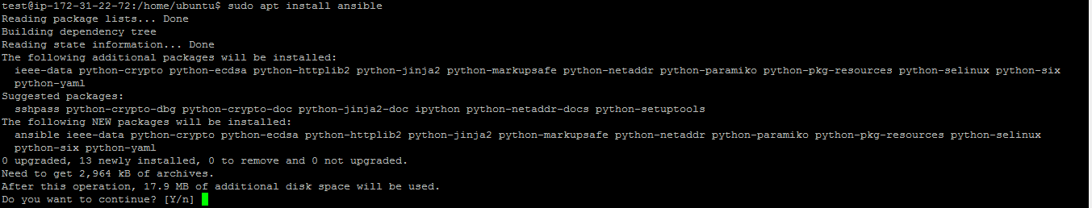

1. Add the IP addresses of the nodes in the Ansible hosts file.

“vi /etc/ansible/hosts“

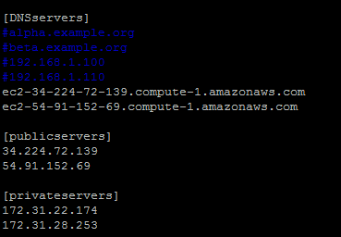

1. After adding the IP addresses in the hosts file, Check the connectivity by performing a ‘ping’

“ansible –m ping DNSservers“

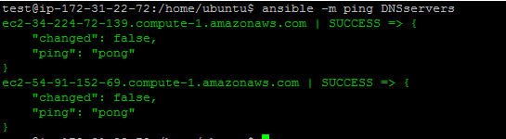

With the above success note, we are successfully able to reach the nodes.

1. Run these ad hoc ansible commands to install git in the nodes.



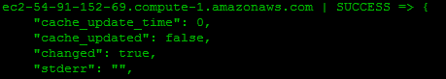

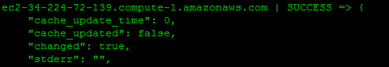

**Ansible Playbooks**

**Ansible Playbooks are used to execute series of commands parallely in node machines.**

**Create a playbook named ‘invent.yml’**

**Playbook for installing tomcat**

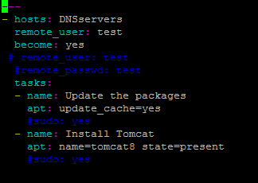

Edit ansible.config



Run the playbook: ansible-playbook invent.yml

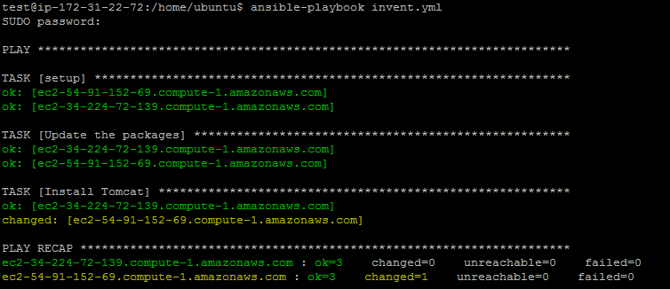

Playbook for installing java

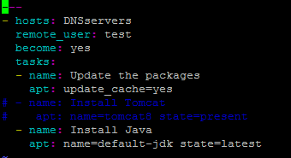

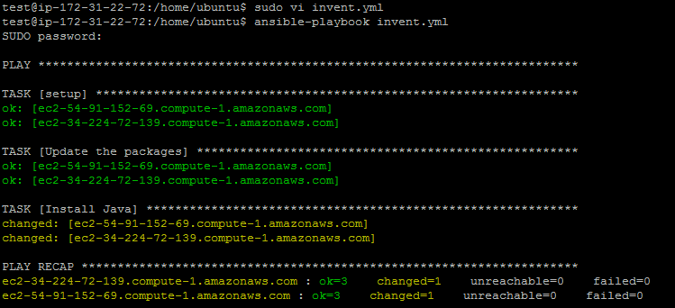

Playbook for starting tomcat:

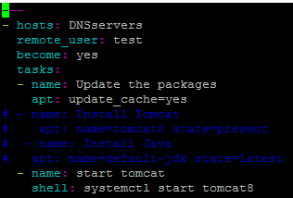

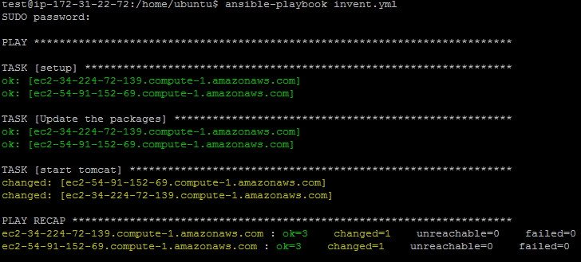

Download and deploy a sample war application:

